setup instructions for oxclo on aws.

1. make sure everything is deleted, security groups, users, instances.
   1. Need to find a way of deleting security groups effectively
2. Create node-security-group and rds security group

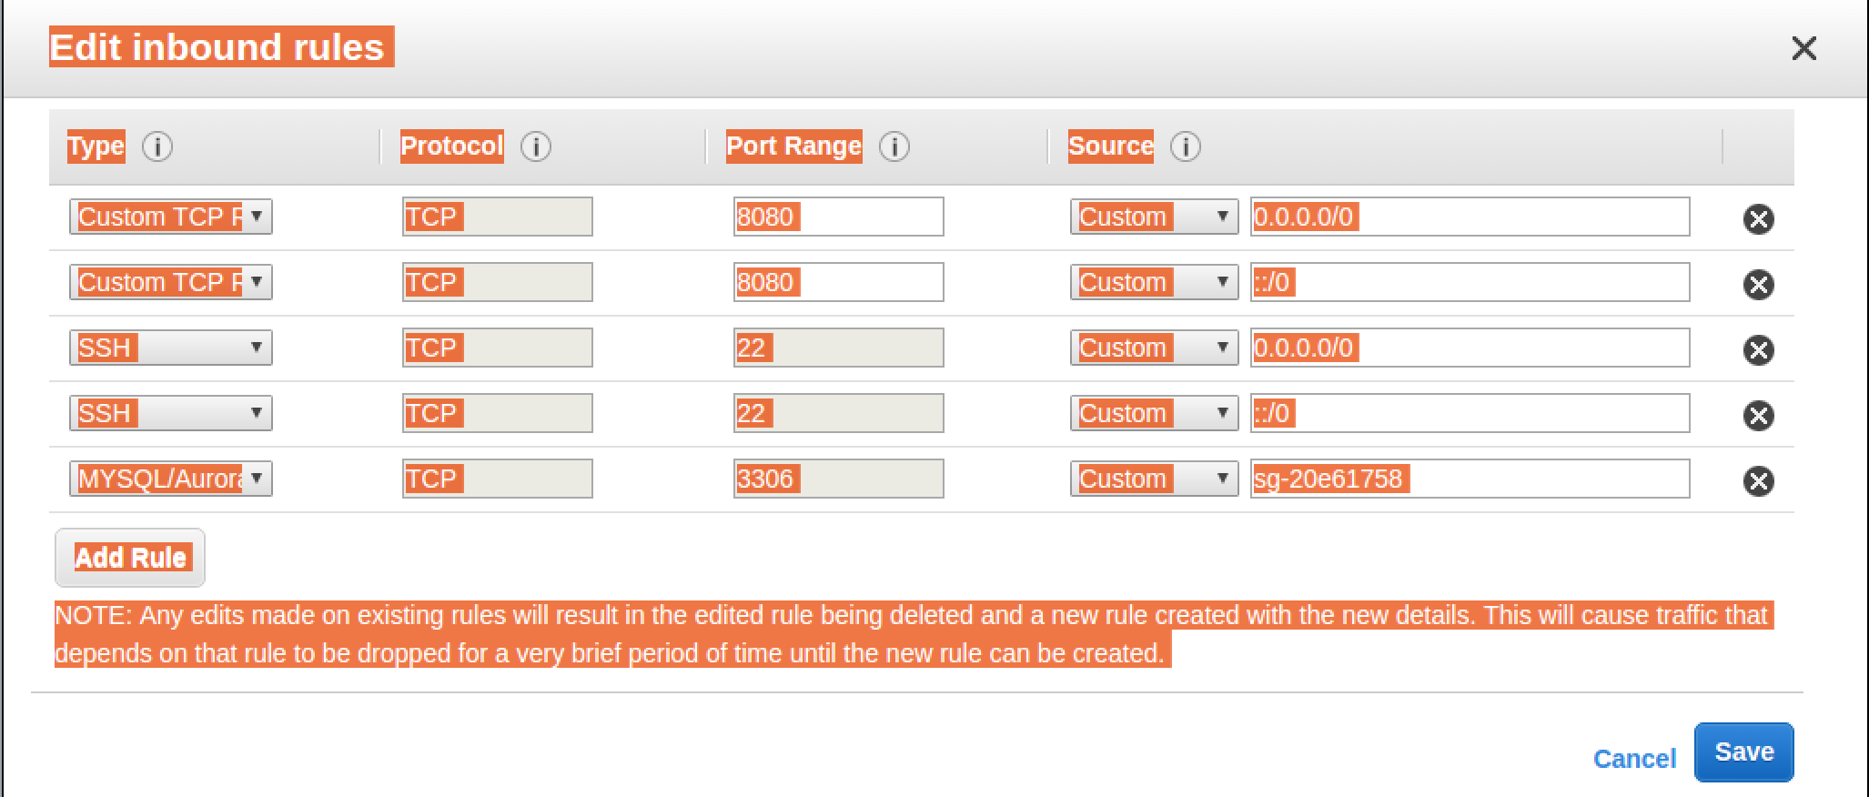

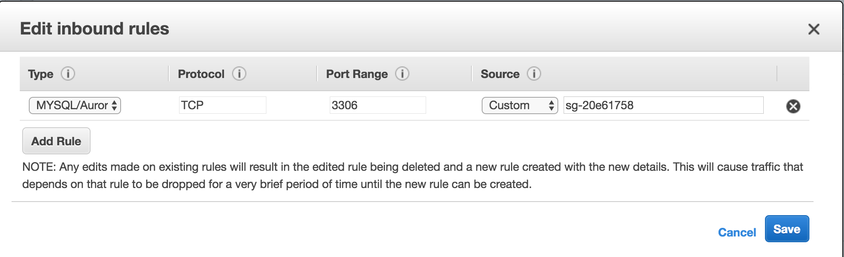

1. create db instance (can I automate this)

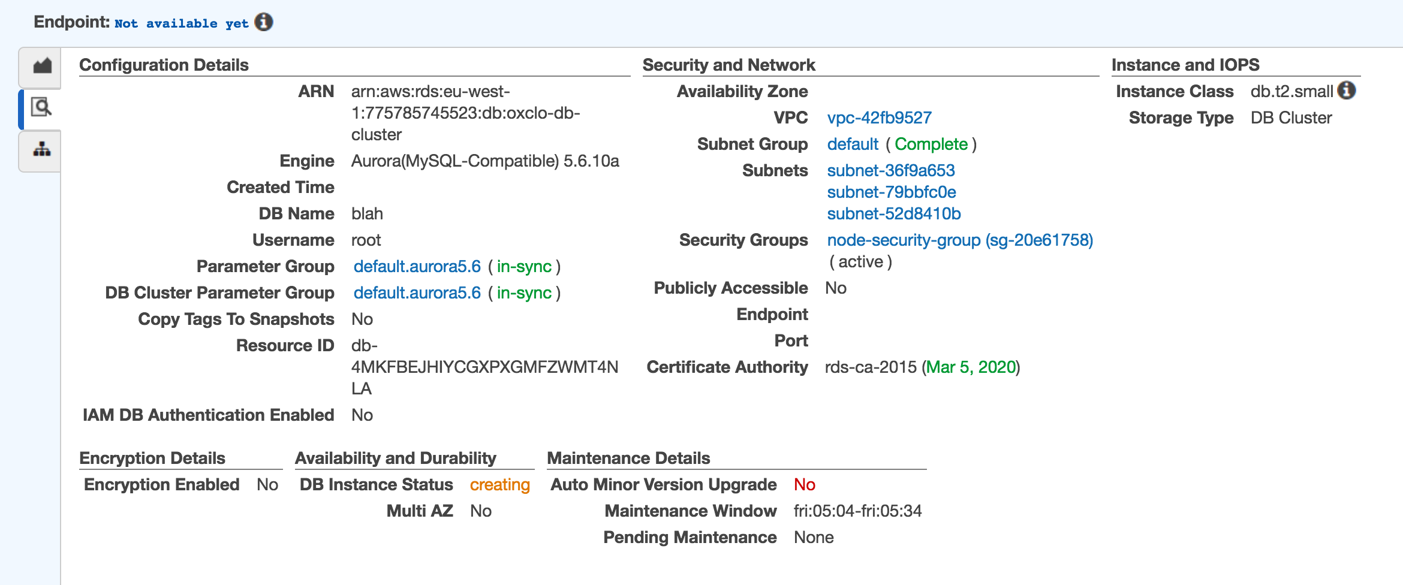

oxclo-cluster.cluster-citfamc1edxs.eu-west-1.rds.amazonaws.com

1. Delete old launch configurations
2. Delete notifications : topics and subscriptions